Step 1 – The date and time on toxic lab virtual environment did match with the time zone in Bellevue because the VM is using the host computer’s resources.

Step 2

Step 3

**Step 4**

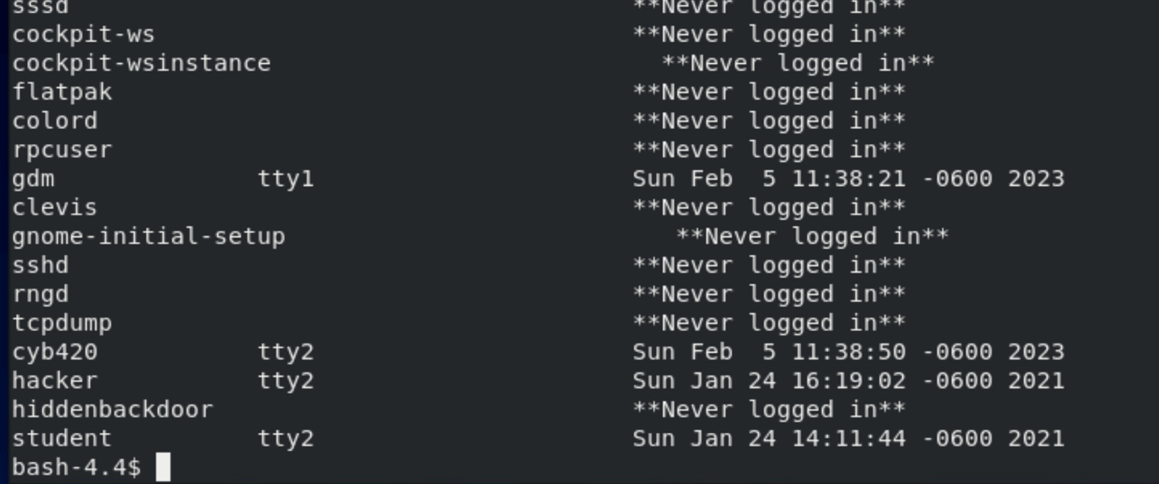

**Step 5 –** Spyware.sh

Step 6 - ReallyBadStuff

